C++

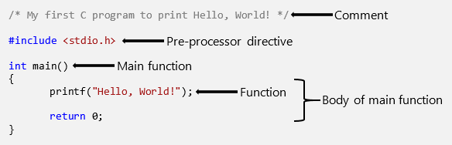

statement and an expression in C?
x = 1
y = x + 1 # an Expression
print y # a Statement

C for Loop
In this tutorial, you will learn to create for loop in C programming with the help of examples.
In programming, a loop is used to repeat a block of code until the specified condition is met.
C programming has three types of loops:
- for loop
- while loop
- do...while loop
We will learn about for loop in this tutorial. In the next tutorial, we will learn about while and do...while loop.

for Loop
The syntax of the for loop is:
for (initializationStatement; testExpression; updateStatement)
{
// statements inside the body of loop
}

for loop Flowchart
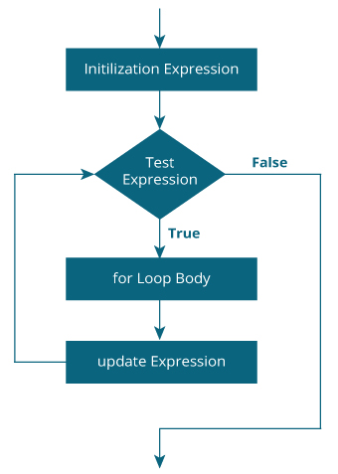

Example 1: for loop
// Print numbers from 1 to 10
#include <stdio.h>

int main() {
int i;

for (i = 1; i < 11; ++i)
{
printf("%d ", i);
}
return 0;
}
Output
1 2 3 4 5 6 7 8 9 10

C Identifiers

Rules for constructing C identifiers
- The first character of an identifier should be either an alphabet or an underscore, and then it can be followed by any of the character, digit, or underscore.
- It should not begin with any numerical digit.
- In identifiers, both uppercase and lowercase letters are distinct. Therefore, we can say that identifiers are case sensitive.
- Commas or blank spaces cannot be specified within an identifier.
- Keywords cannot be represented as an identifier.
- The length of the identifiers should not be more than 31 characters.
- Identifiers should be written in such a way that it is meaningful, short, and easy to read.
Example of valid identifiers
total, sum, average, _m _, sum_1, etc.

Differences between Keyword and Identifier
Keyword Identifier
- Keyword is a pre-defined word. The identifier is a user-defined word.
- It must be written in a lowercase letter. It can be written in both lowercase and uppercase letters.
- Its meaning is pre-defined in the c compiler. Its meaning is not defined in the c compiler.
- It is a combination of alphabetical characters. It is a combination of alphanumeric characters.
- It does not contain the underscore character. It can contain the underscore character.

Let's understand through an example.
int main()
{
int a=10;
int A=20;
printf("Value of a is : %d",a);
printf("\nValue of A is :%d",A);
return 0;
}

Output
Value of a is : 10
Value of A is :20

The above output shows that the values of both the variables, 'a' and 'A' are different. Therefore, we conclude that the identifiers are case sensitive.

What is Token in C?
TOKEN is the smallest unit in a 'C' program. It is each and every word and punctuation that you come across in your C program. The compiler breaks a program into the smallest possible units (tokens) and proceeds to the various stages of the compilation. A token is divided into six different types, viz, Keywords, Operators, Strings, Constants, Special Characters, and Identifiers.

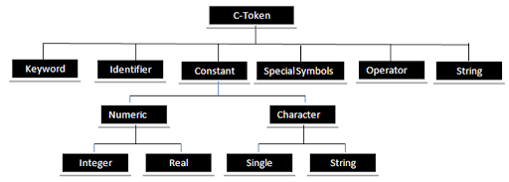
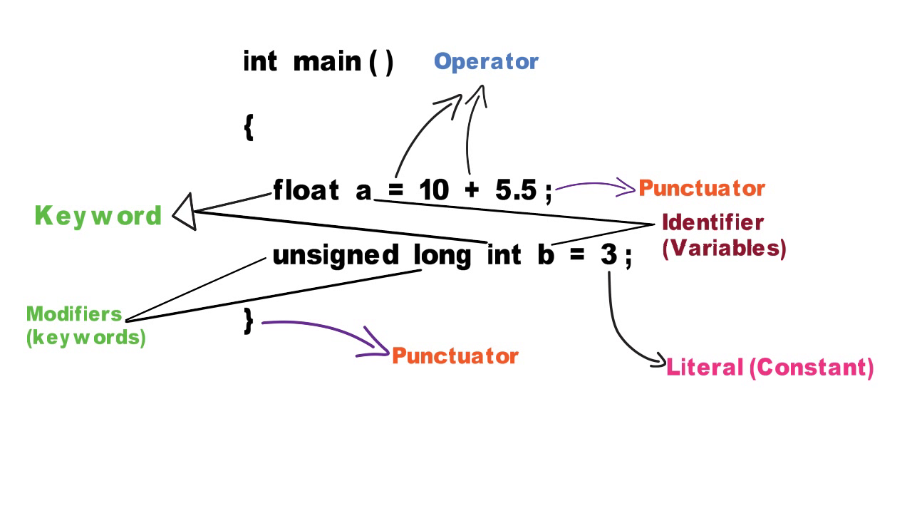
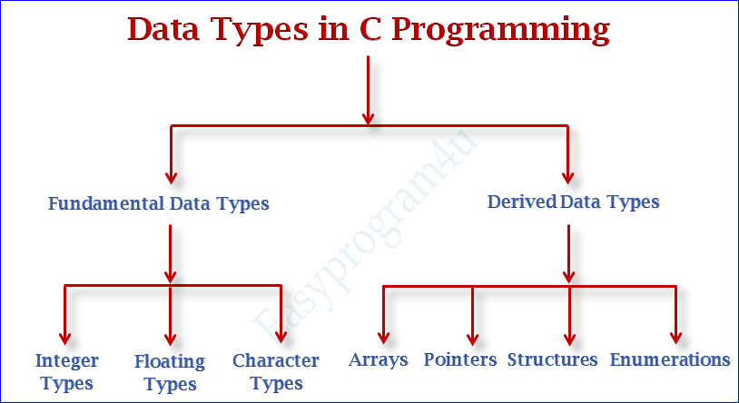

Variables
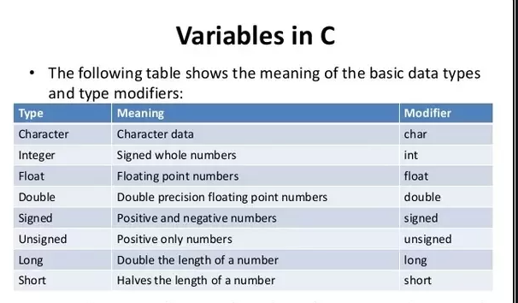
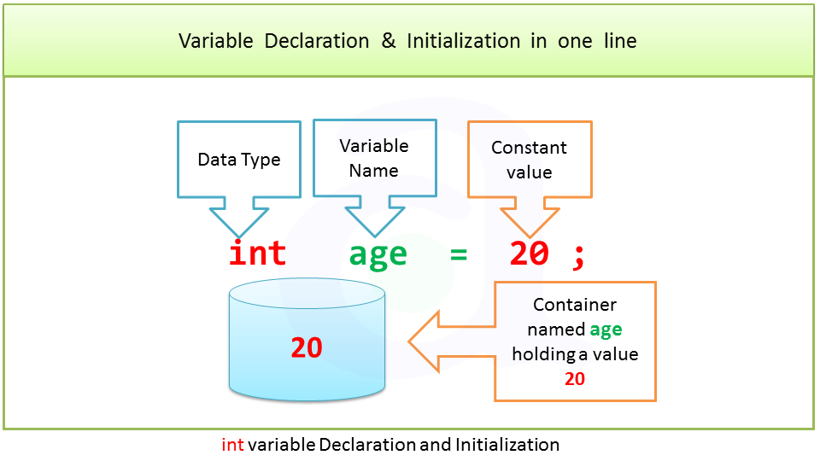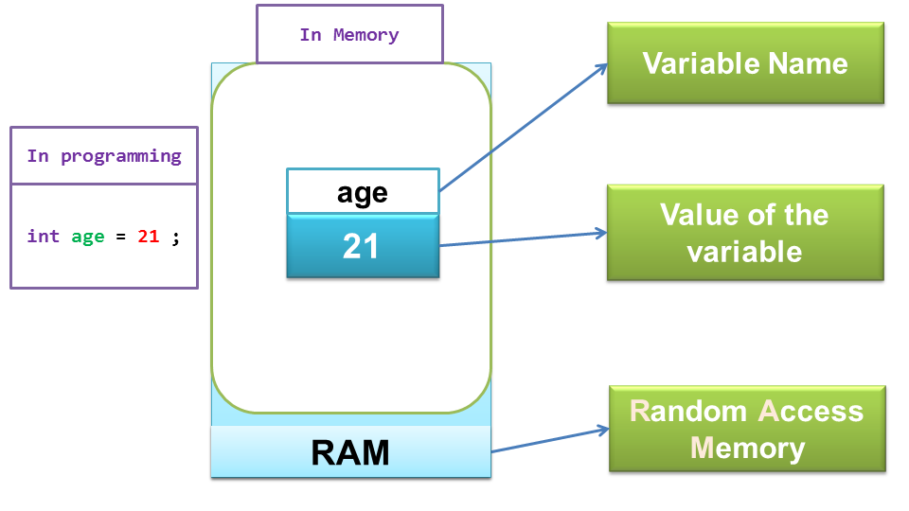

Pointer

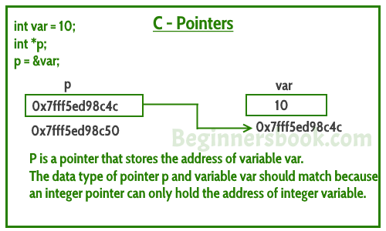
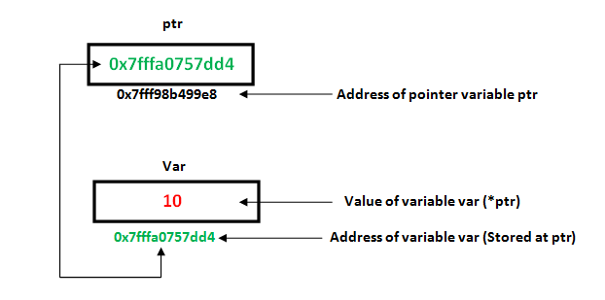
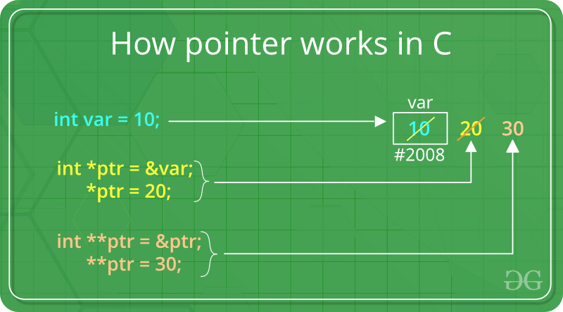

References
Example

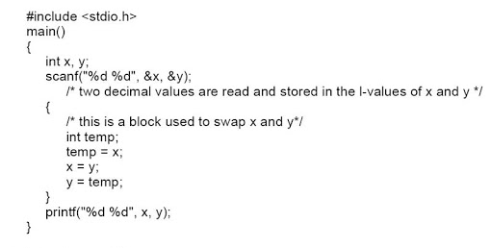

Structure

Below image shows syntax:
struct structure_name
{
data_type member1;
data_type member2;
.
.
data_type memeberN;
};

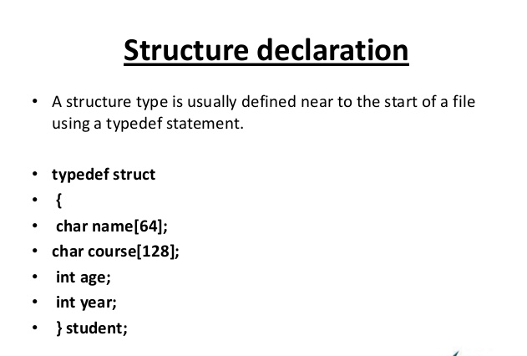

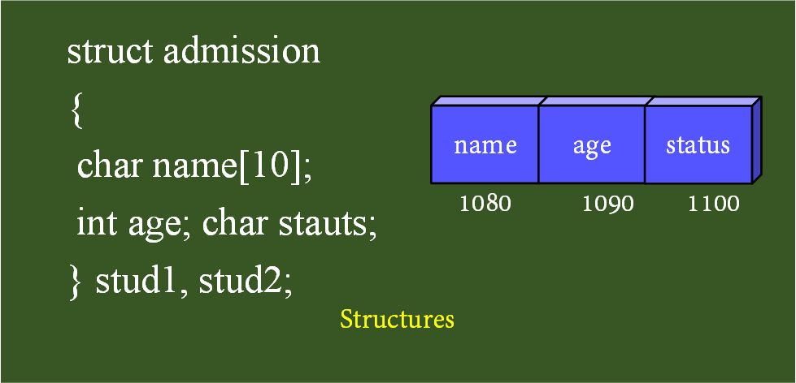

struct employee
{ int id;
char name[20];
float salary;
}e1,e2;
The variables e1 and e2 can be used to access the values stored in the structure. Here, e1 and e2 can be treated in the same way as the objects in C.

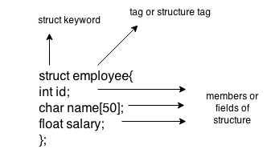
Accessing members of the structure
There are two ways to access structure members:
By . (member or dot operator)
By -> (structure pointer operator)

Example
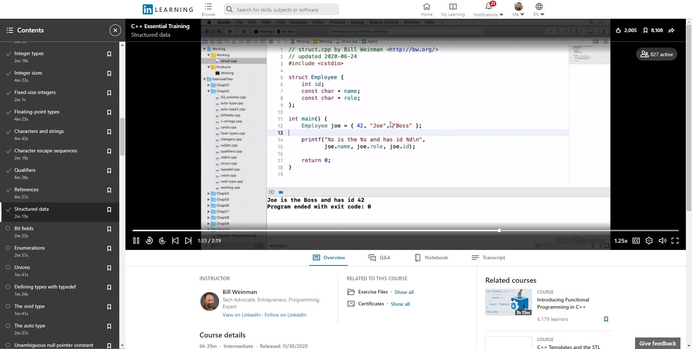

Function

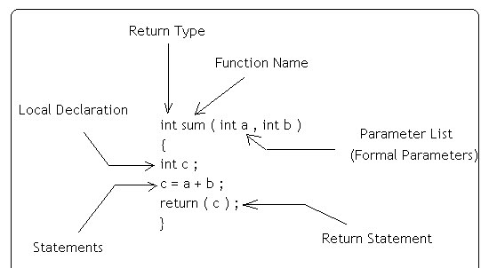

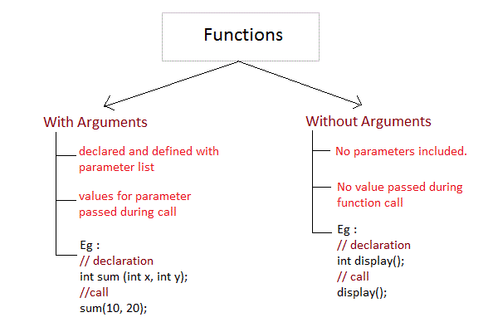

#include <stdio.h>

// An example function that takes two parameters 'x' and 'y'
// as input and returns max of two input numbers

int max(int x, int y)
{
if (x > y)
return x;
else
return y;
}

// main function that doesn't receive any parameter and
// returns integer.

int main(void)
{
int a = 20, b = 30;

// Calling above function to find max of 'a' and 'b'

int m = max(a, b);

printf("maximum is %d", m);
return 0;
}

Out put
Maximum is 30

Classes
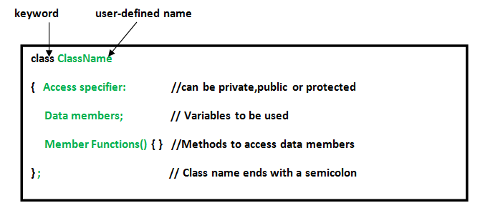

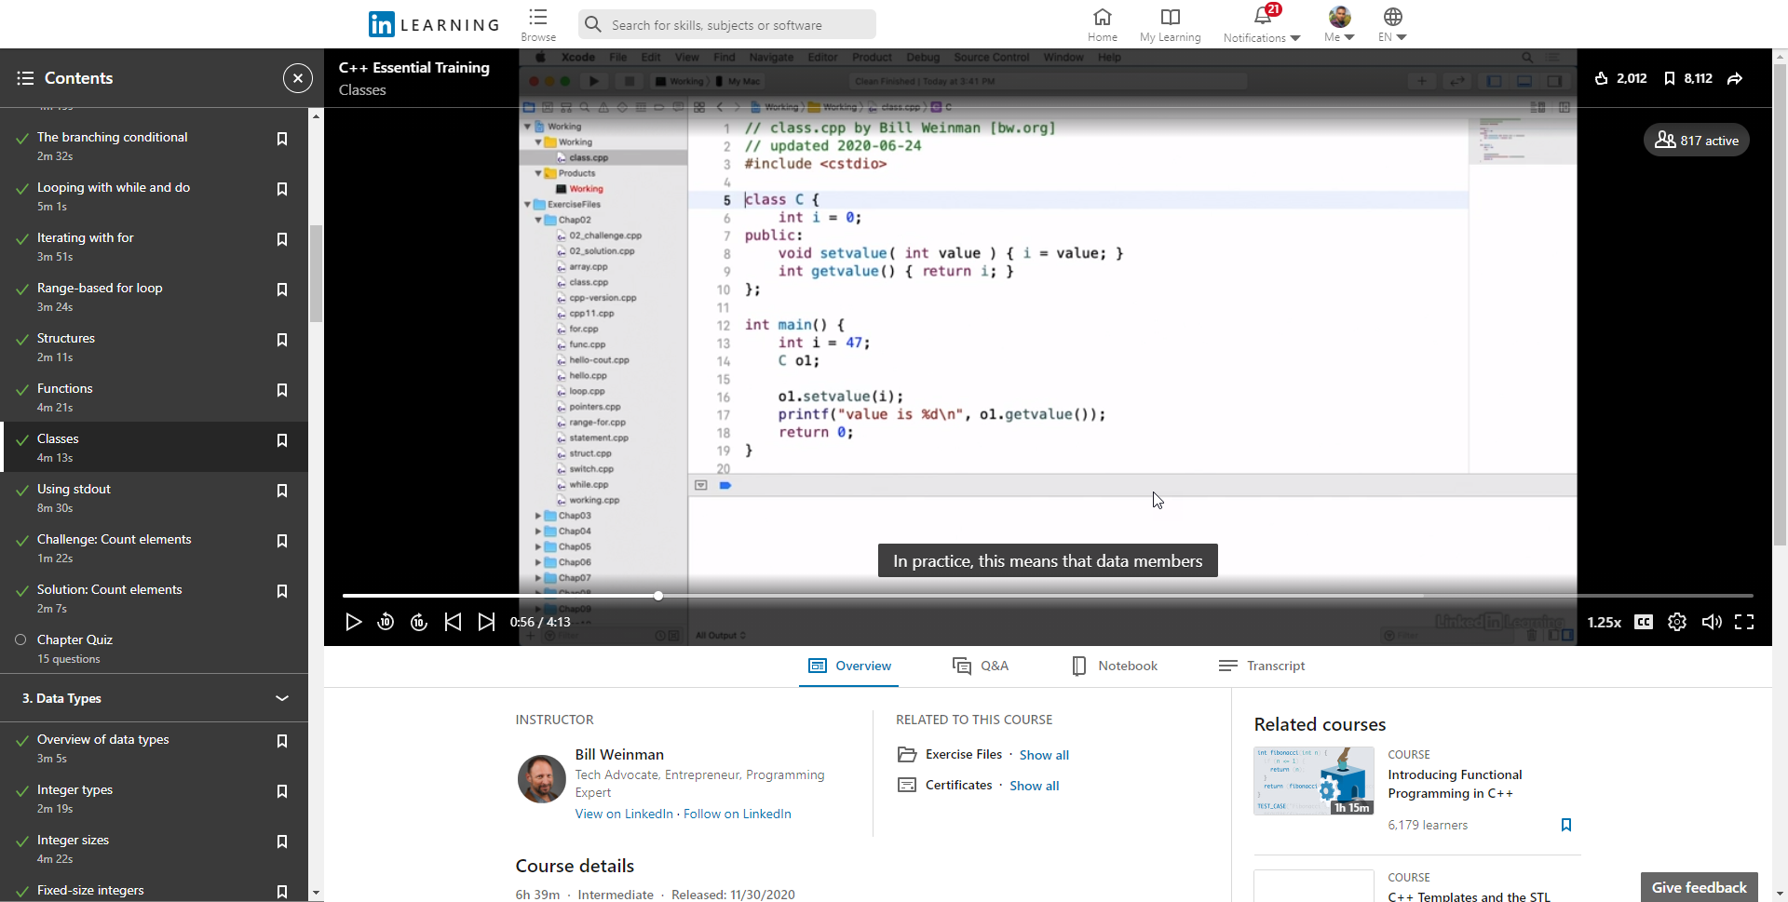

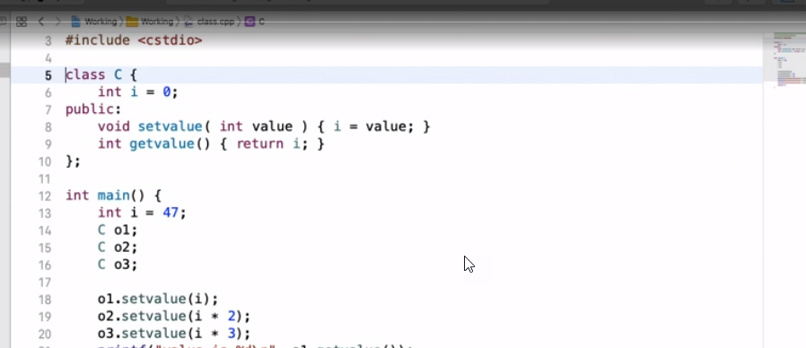
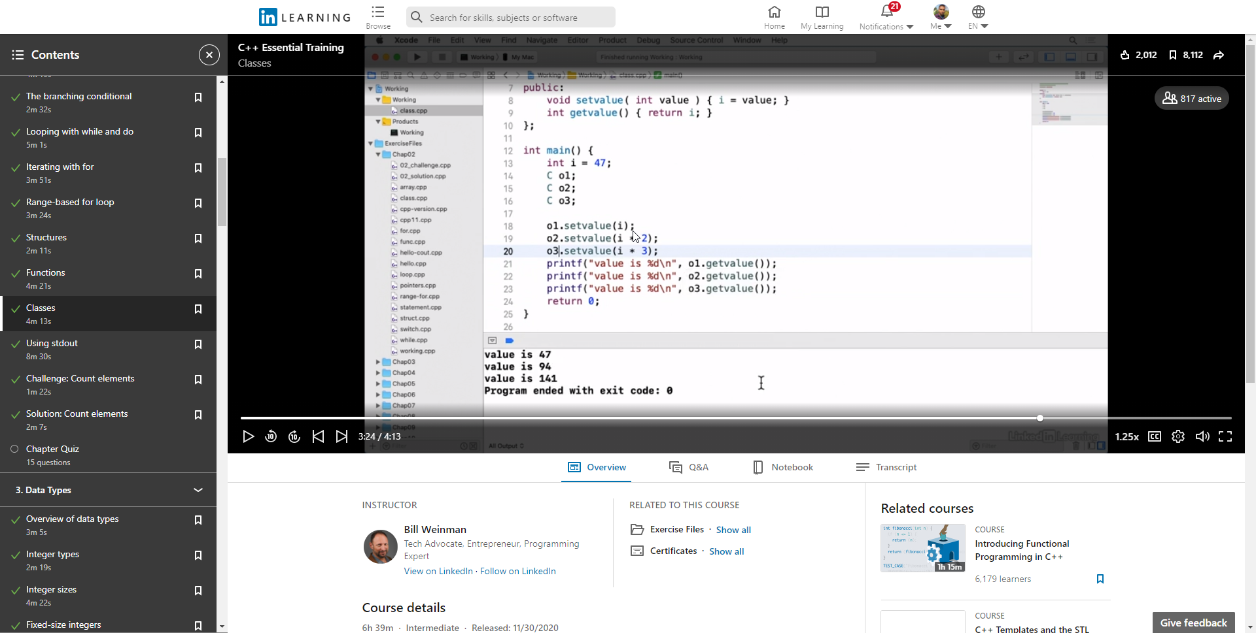

Hello Sir,
I have spoken to Vrushali about Contributor Change name in Lesson Learnt and she is agreed on that and I have raised a ticket for Lesson Learnt change in Contributor name for this from KJ Page.
Please let me know if any concerns.
Regards,
Durgeshkumar Gupta

